МІНІСТЕРСТВО ОСВІТИ І НАУКИ УКРАЇНИ

Міжнародний гуманітарний університет

Алгоритмізація та програмування

**Практична робота № 3**

*Виконав:*

Ілієв Гліб Георгиевич ІКТ-2.1

*Перевірив викладач:*

Клімішина І. В.

Одеса-2022

Варiант 6

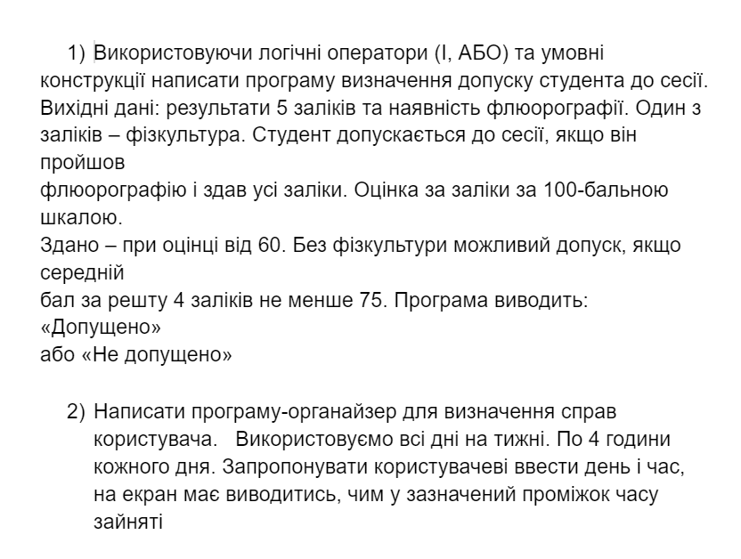

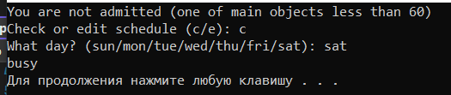

#define _USE_MATH_DEFINES

#include <iostream>

#include <cmath>

using namespace std;

int main()

{

short math = 80, eng = 20, ukr = 80, physcult = 80, hist = 80;

bool fulrografiya = false;

if (fulrografiya == true) {

if (math < 60 || eng < 60 || ukr < 60 || hist < 60) {

printf("NOT admitted (one of main objects less than 60)");

}

else if (physcult < 60) {

if ((math + eng + ukr + hist) / 4 > 75) {

printf("Admitted");

}

else {

printf("NOT admitted(your physcult less than 60 and avarage mark less than 75)");

}

}

else {

printf("Admitted");

}

}

else {

printf("NOT admitted (you don`t have flour)");

}

string sun = "busy", mon, tue = "busy", wed = "busy", thu, fri = "busy", sat="busy";

string user_answer;

printf("\nCheck or edit schedule (c/e): ");

cin >> user_answer;

if (user_answer == "c") {

printf("What day? (sun/mon/tue/wed/thu/fri/sat): ");

cin >> user_answer;

if (user_answer=="sun") {

cout << sun << endl;

}

else if (user_answer == "mon") {

cout << mon << endl;

}

else if (user_answer == "tue") {

cout << tue << endl;

}

else if (user_answer == "wed") {

cout << wed << endl;

}

else if (user_answer == "thu") {

cout << thu << endl;

}

else if (user_answer == "fri") {

cout << fri << endl;

}

else if (user_answer == "sat") {

cout << sat << endl;

}

else {

printf("Wrong day");

}

}

else if (user_answer == "e") {

printf("What day?(sun/mon/tue/wed/thu/fri/sat)");

cin >> user_answer;

if (user_answer == "sun") {

cout << sun << endl;

printf("Enter your new plan");

cin >> sun;

}

else if (user_answer == "mon") {

cout << mon << endl;

printf("Enter your new plan");

cin >> mon;

}

else if (user_answer == "tue") {

cout << tue << endl;

printf("Enter your new plan");

cin >> tue;

}

else if (user_answer == "wed") {

cout << wed << endl;

printf("Enter your new plan");

cin >> wed;

}

else if (user_answer == "thu") {

cout << thu << endl;

printf("Enter your new plan");

cin >> thu;

}

else if (user_answer == "fri") {

cout << fri << endl;

printf("Enter your new plan");

cin >> fri;

}

else if (user_answer == "sat") {

cout << sat << endl;

printf("Enter your new plan");

cin >> sat;

}

else {

printf("You entered wrong day\n");

}

}

system("pause");

return 0;

}